# JS Advanced: Exam 26 April 2018

Problems for exam preparation for the [“JavaScript Advanced” course @ SoftUni](https://softuni.bg/courses/javascript-advanced). Submit your solutions in the SoftUni judge system at <https://judge.softuni.bg/Contests/1004/>.

# Problem 4. Public Transport (Object Interacting with DOM)

Write a JS **class** with the name **"PublicTransportTable"** that generates and controls a **public transport** table. It contains **two main columns** for transport data **(Type, Name)** and **one column** for **Actions - [Search]**, **[Clear]** and **[More/Less Info]** buttons**.** The **second row** of the table consists of **two** **input fields, [Search]** and **[Clear]** button. The **main table’s** body consists of rows with **types** of **vehicles** with additional **inner tables** for more information. Every **vehicle** has a **main info row** and an **additional info row**. *See the examples and templates for more details.*

The **constructor** of your class needs to take **one** argument – **town** (string). The **town** should replace in the table’s title (<caption>) the part in the curly brackets. *See the main table’s HTML for more details below*.

Additionally, the **class** **should** **contain** the following **functionality**:

* Function addVehicle(obj)– takes **one** (object) argument, **creates** the **vehicle’s main info row** (see the template)and **appends** it to the **main table’s body** with **ID** of **"vehicles-info"**. The **argument** is in the following format:

{ type: String, name: String, route: String, price: Number, driver: String }

With this object’s data you should create a **table’s row** following this **HTML structure:**

|  |
| --- |
| Template Vehicle’s Main Info Row |
| <tr>  <td>*<!-- Vehicle's type -->*</td>  <td>*<!-- Vehicle's name -->*</td>  <td><button>[More/Less] Info</button></td>  </tr> |

When a vehicle’s **row** is created its **initial button’s** **text** should be **"More Info".** Also, when **clicked** a **[More Info] button** should have the following **functionality:**

* **Changes its text** to **"Less Info"**
* **Creates below** the table’s **row where it is placed on** a new **row** with the **vehicle’s additional info data**. You should use the following **HTML structure** **for** generating the **new row** with **inner table:**

|  |
| --- |
| Template Vehicle’s Additional Info Row |
| <tr *class*="more-info">  <td *colspan*="3">  <table>  <tr><td>Route: {vehicle's route}</td></tr>  <tr><td>Price: {vehicle's price}</td></tr>  <tr><td>Driver: {vehicle's driver}</td></tr>  </table>  </td>  </tr> |

An **additianal vehicle’s row** consists of a **row** with a **single column** that have an **inner table** with **four rows** each having a **single column** with a vehicle data.

Furthermore, when a **[Less Info] button is clicked**, it should have the following **functionality:**

* **Changes its text** to **"More Info"**
* **Removes the row** (below the table’s row where it is placed on)with the **extra** **vehicle’s data**

Also, when **clicked** the **[Search]** and **[Clear] buttons** should have the following **functionality**:

**[Search] button:**

* **Filters** the **vehicles** by the **text** received from the **input boxes** (**case-sensitive**)**.** Every **input box** corresponds to the **vehicle’s column** it is **placed on**. You should **show** a **row** (remove **"display: none;"**) If its **columns include** the **text** from thetheir **corresponding text box** or **hide** it if they do not include(set **"display: none;"**)
* **Removes** any **additional** **vehicle** **rows,** that are **displaying** the **extra data** (route, price, driver), if the **main row** should be **removed** and **sets** its **button text** from **[Less Info]** to **[More Info]**
* **Do nothing** if **both** **input boxes** are **empty**

**[Clear] button:**

* **Removes** all **filters** and **displays all main vehicle rows**
* **Does nothing** to **additional** **vehicle** **rows**
* **Clears** the **input boxes**

### Submission

Submit only your **PublicTransportTable** class.

### Examples

You should use the following HTML skeleton to test your functionality:

|  |
| --- |
| index.html |
| <!DOCTYPE html>  <html *lang*="en">  <head>  <meta *charset*="UTF-8">  <title>Payment Manager</title>  <style>  body{padding:30px}caption,table{border:1px solid #b1cbbb}table{border-collapse:collapse;margin:auto}caption{font-size:20px;font-weight:700;color:#DEEAEE;background:#485788;border-bottom:none;padding:5px}td,th{padding:5px 20px;text-align:center}tfoot td,th{background:#b1cbbb}tr*:nth-child*(odd){background:#EAF7FB}tr*:nth-child*(even){background:#C6D1D4}button{margin:auto;cursor:pointer}input[*type*=text]{width:100px}tbody>.more-info{background:#E6F1B4!important}tbody tr table{margin:5px auto 5px 20px;width:330px;}tbody tr table td{background:#eea29a99!important;text-align:left;width:170px}  </style>  <script *src*="https://code.jquery.com/jquery-3.3.1.min.js"></script>  </head>  <body>  <table>  <caption>{Town name}'s Public Transport</caption>  <thead>  <tr>  <th *class*="type">Type</th>  <th *class*="name">Name</th>  <th>Actions</th>  </tr>  <tr>  <td><input *name*="type" *type*="text"></td>  <td><input *name*="name" *type*="text"></td>  <td>  <button *class*="search-btn">Search</button>  <button *class*="clear-btn">Clear</button>  </td>  </tr>  </thead>  <tbody *class*="vehicles-info"></tbody>  </table>  <script *src*="./solution.js"></script>  <script>  $(function() {  let publicTransportTable = new PublicTransportTable('Sofia')    let vehiclesDataArr = [  { type: 'bus', name: '84', route: 'Sofia airport - Gen. Gurko str.', price: 1.60, driver: 'Pesho' },  { type: 'tram', name: '7', route: 'Borovo - metro station Han Kubrat', price: 13.37, driver: 'Misho' },  { type: 'bus', name: '280', route: 'Student city - SU Kliment Ohridsky', price: 4.20, driver: 'Gosho' },  { type: 'trolleybus', name: '11', route:' Drujba 1 - Stochna station sq.', price: 2.60, driver: 'Tosho' },  { type: 'metro', name: 'M1', route:'Slivnica - Business Park', price: 3.50,  driver: 'Petq' },  { type: 'bus', name: '404', route: 'AP Drujba - Central station', price: 1.60,  driver: 'Silviq' },  { type: 'metro', name: 'M2', route:'Sofia airport - James Bourchier', price: 5.99, driver: 'Krum' },  *// You can add/remove any vehicles data objects here*  ]  *for* (let vehicleObj of vehiclesDataArr) {  publicTransportTable.addVehicle(vehicleObj)  }  })  </script>  </body>  </html> |

The sample page contains the main table element whit head, body and a script. The script will populate the table’s body with seven main vehicles info rows that should look like the examples, if your code is correct. You need to put the files – index.html and solutions.js (where is your PaymentManager class) – in the same directory for them to work with the default code.

In the examplewe will use only the seven objects with vehicle’s data in the script to generate and manipulate the table’s functionality.

**Initial table rendering with vehicles**:

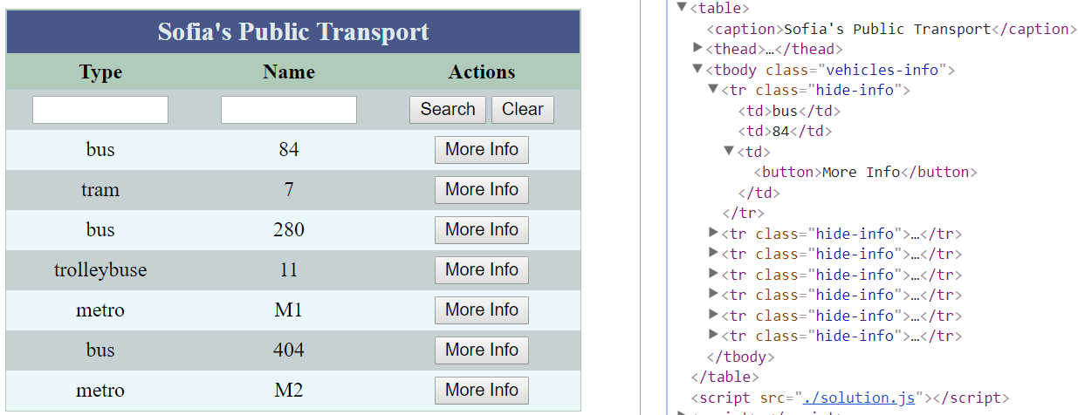

Use the "Template Main Info Rows" skeleton to build your main vehicles rows.

**Click** the **[More Info] button** on bus 280’s row:

After the click we **change** the **button’s** **text** to "**Less Info**" and **add** the **additional vehicle’s info row** **below** the **main one**. Thus becoming **7** **main** and **1 additional vehicle info rows** (8 total) in the main table (vehicles-info)**.** As shown by the red lines below.

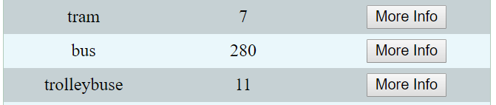

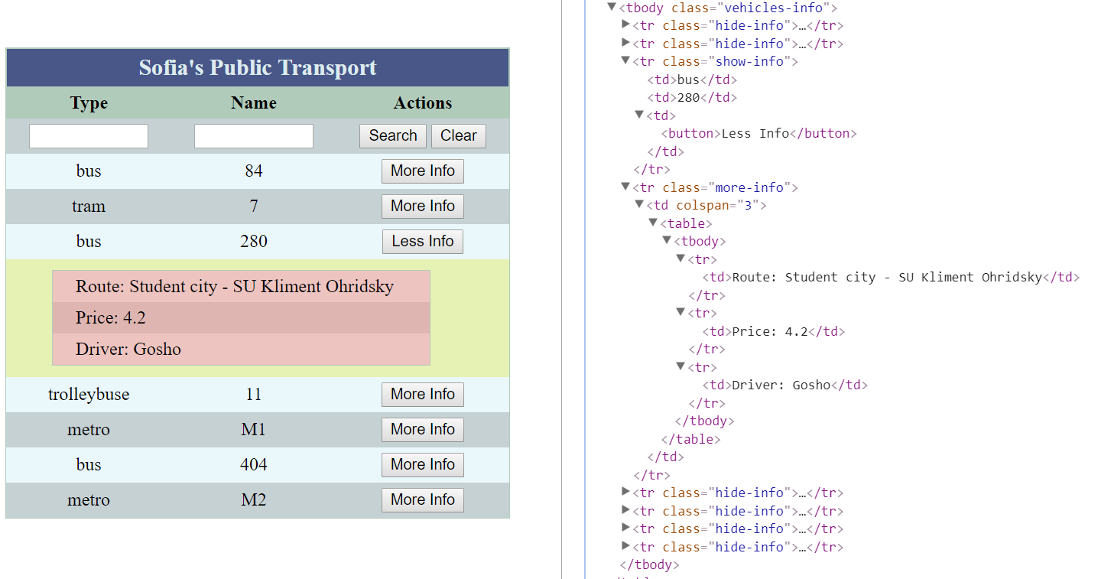

**Click** the **[Less Info] button** on bus 280’s row:

After the click we **change** the **button’s** **text** to "**More Info**" and **remove** the **additional vehicle’s info row** **below** the **main one**. Thus becoming **7** **main** and **no additional vehicle info rows** in the main table (vehicles-info) again**.** As shown by the red lines below.

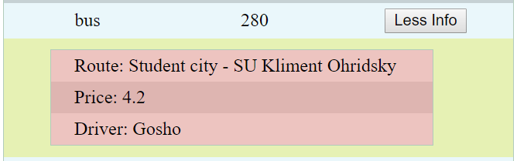

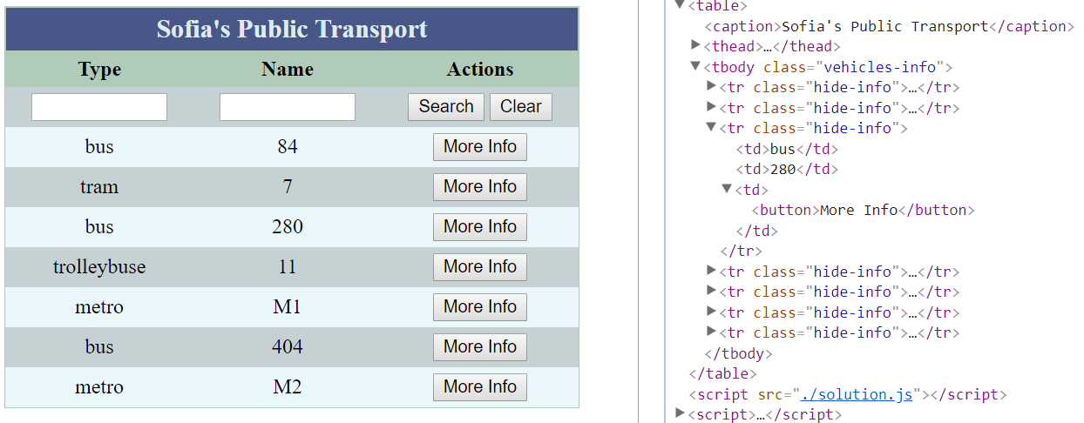

Then we **enter** "**bu**" in the **input box** on **column** "**Type**"and **click** the **[Search] button:**

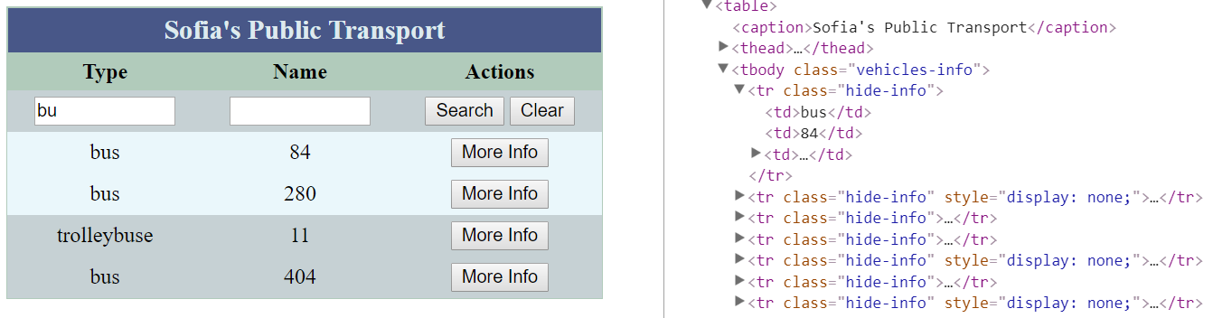

After that, we **click** the **[More Info] button** on trolleybus 11’s row:

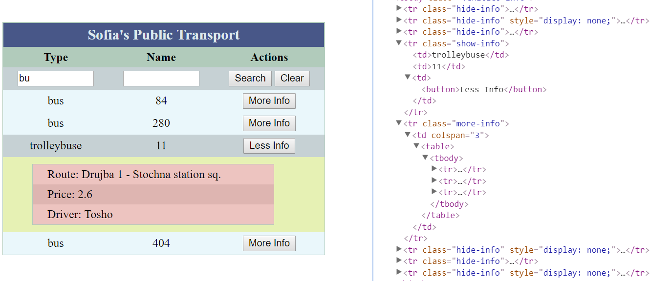

8 rows – 4 visible; 3 hidden; 1 extra (additional)

Then we **click** the **[Clear] button**:

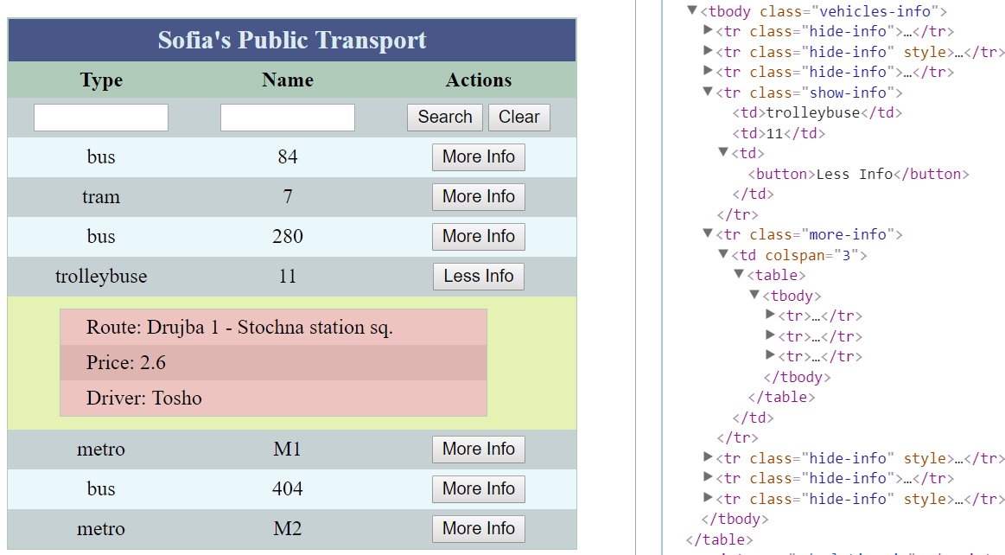

Chain of **commands** to the table:

* **Click [More Info]** **button** on **bus 404, metro M2, tram 7, bus 84**
* **Enter** "**ro**" in the **input box** on **column** "**Type**","**1**" in the **input box** on **column** "**Name**" and then **click** the **[Search] button**

Chain result:

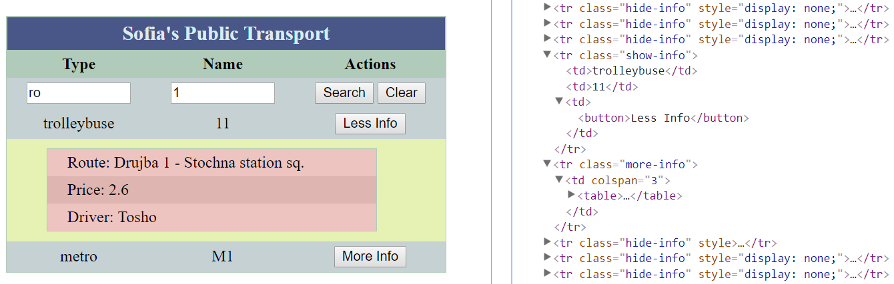

Chain of **commands** to the table:

* **Click [Less Info]** **button** on **trolleybus 11**
* **Click [More Info] button** on **metro M1**
* **Click [Clear] button**
* **Click [More Info] button** on **bus 404, bus 84, metro M2**

Scroll down to see result:

